JMeter Performance Testing

Introduction
This report presents the results of performance testing conducted on the SauceDemo website using Apache JMeter, to measure how well the website performs under different levels of demand, the main goal of this testing was to evaluate how the website behaves when a large number of users access it at the same time and checking whether it can handle that load without slowing down, crashing, or returning errors.

Steps
1. create a Test Plan, inside it, create a Thread Group
2. Define the number of virtual users, ramp up time, and loop
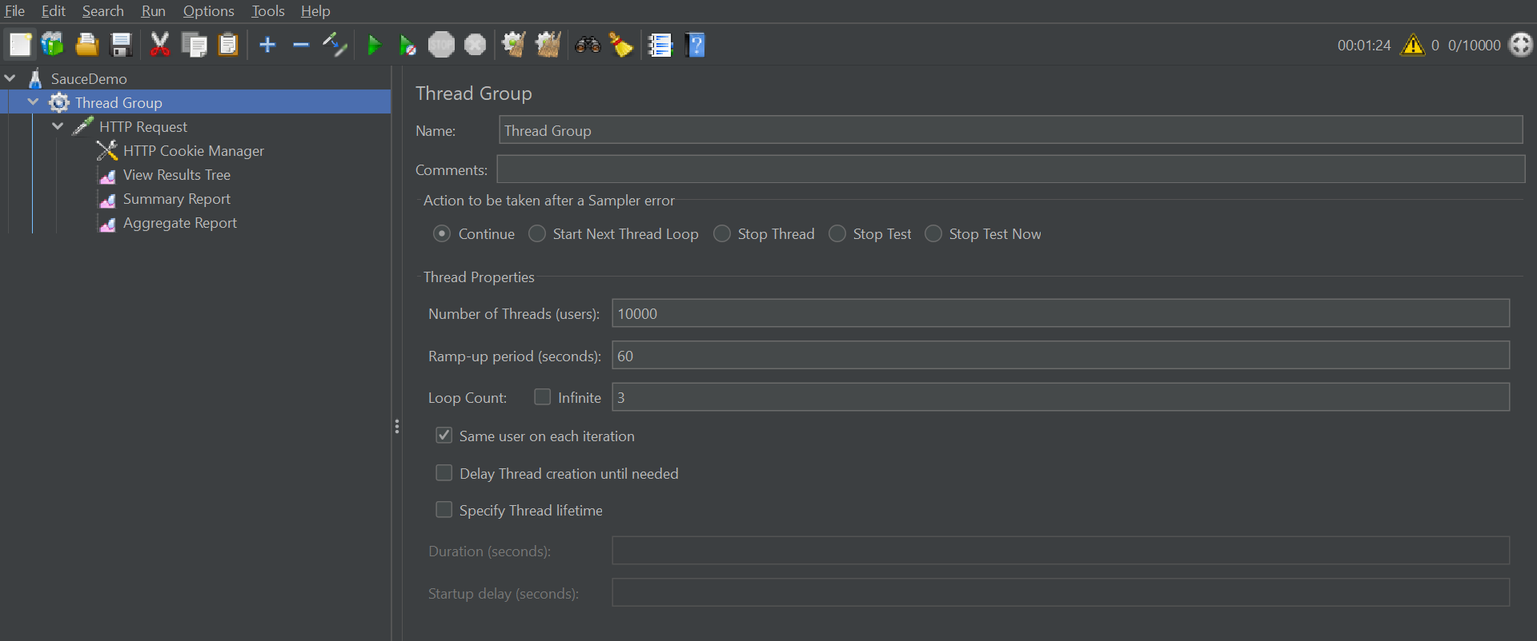

3. Define the HTTP Sampler
4. Using Get Request
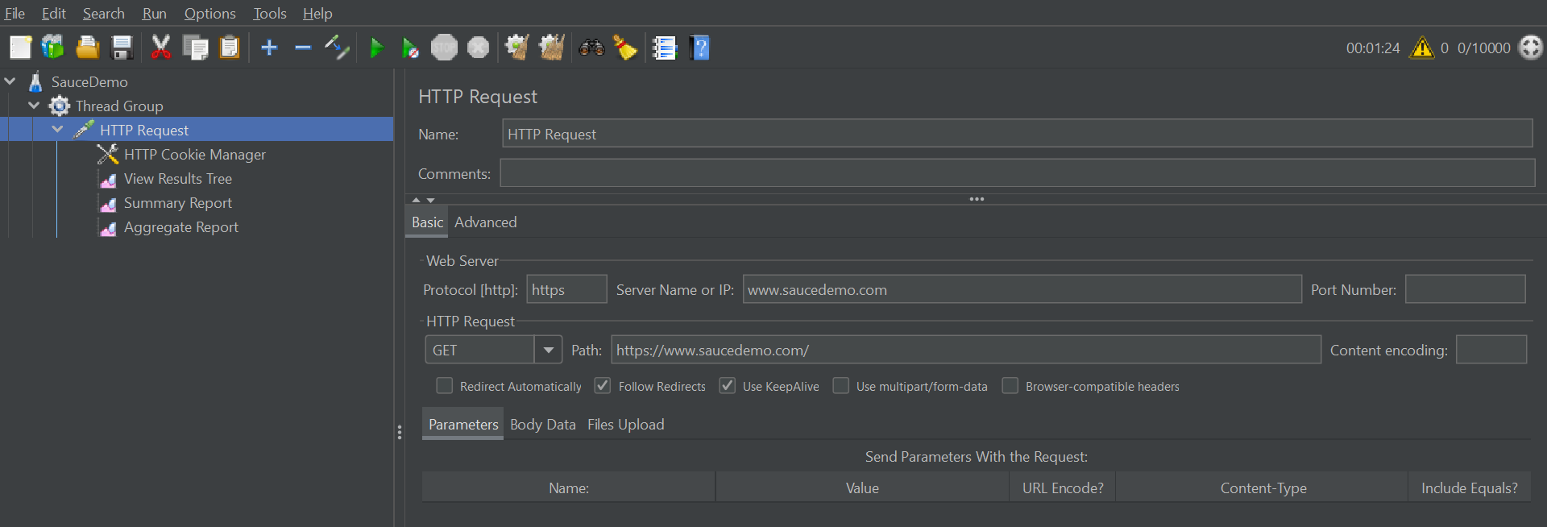

5. Define the listener
6. View Results Tree
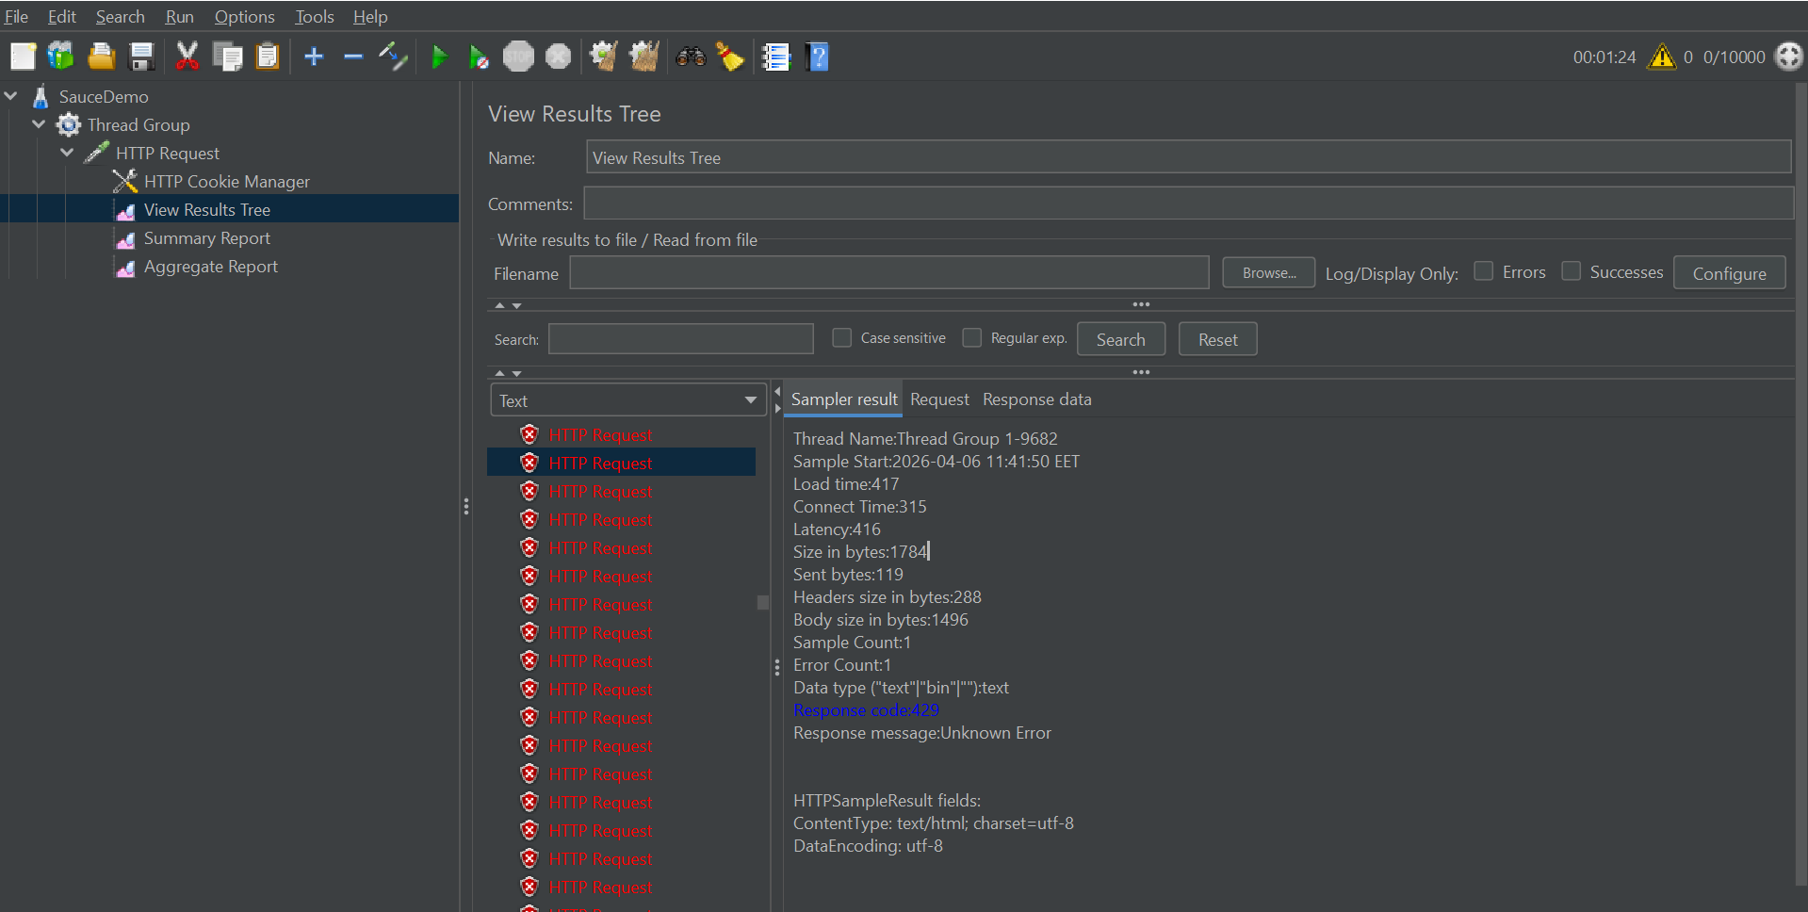

7. Summary Report
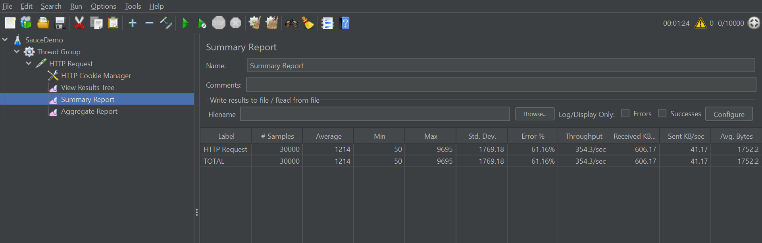

8. Aggregate Report
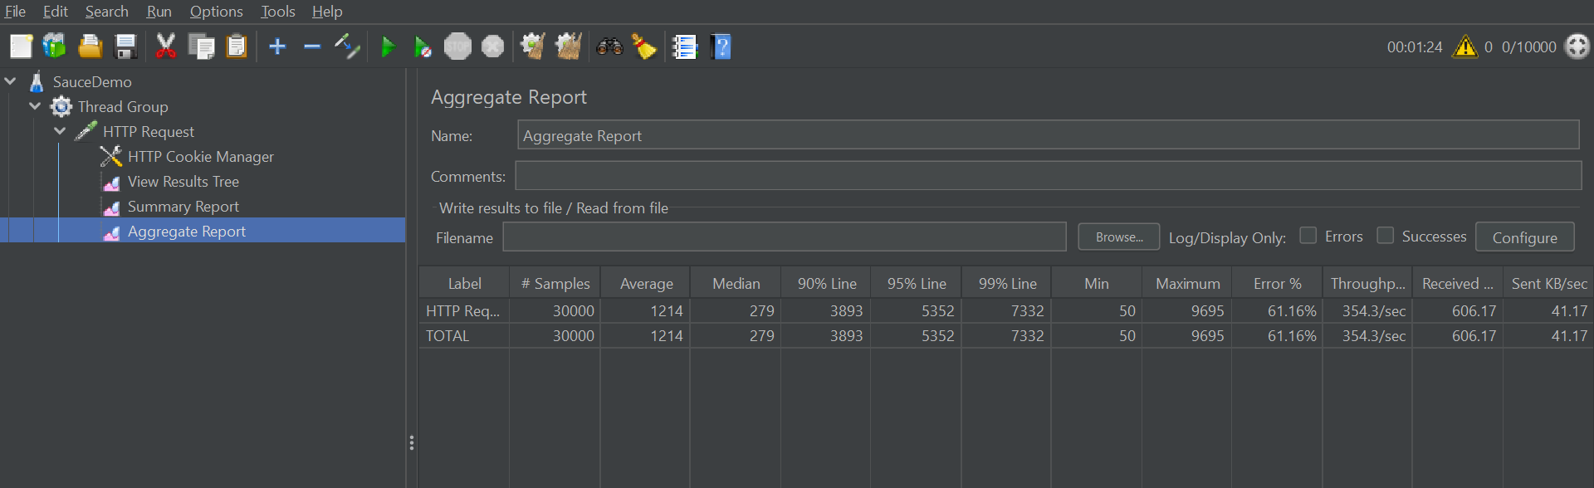

Security Testing
This security testing was carried out on the SauceDemo website using OWASP ZAP to identify security vulnerabilities in the website. The purpose of this testing was to examine whether the website contains any weaknesses that could potentially be exploited by attackers, such as insecure configurations, exposed server information, or improper handling of user data, it automatically scanned the website and flagged a number of security alerts, each varying in risk level.
The identified issues are listed and explained below

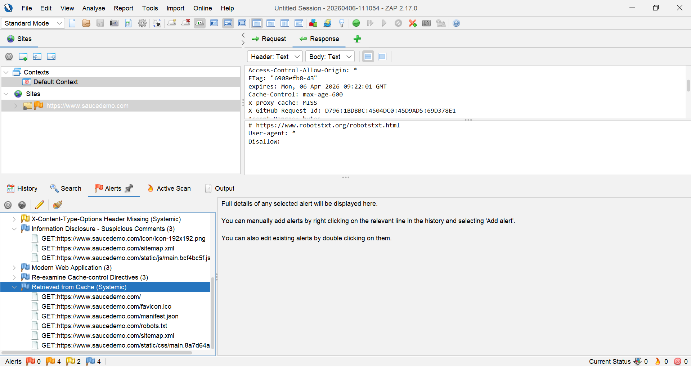
HTTP Response Headers that ZAP flagged:
1. Access-Control-Allow-Origin: *
It means the server allows any website on the internet to make requests to this resource and read the response, and it could result in a malicious website could send requests to Swag Labs on behalf of a logged-in user and steal data

2. X-GitHub-Request-Id: D796:1BDBBC:...
It reveals that the site is hosted on GitHub Pages, which could make an attacker know the hosting platform, which helps them look for GitHub Pages specific vulnerabilities or misconfigurations

3. Expires: Mon, 06 Apr 2026 09:22:01 GMT
It means the browser is allowed to catch this resource by the given date/time. If the cached content contains sensitive data (for example: user info, tokens), it could be read from the browser cache by another user on the same machine

